Elevator Week 3: Controller Fine Tuning

**Objective**: Improve the performance of your controller from week 2

**Deliverables:**

1.) Demonstration allowing user to set elevator height in inches, elevator responds

2.) Lab report presenting your process and results

This week you will improve your controller block. You will evaluate how effective your controller is by treating the **entire system** as a single block with an input (desired height) and output (actual height). You will summarize the entirety of your results from Lab 5 in a report.

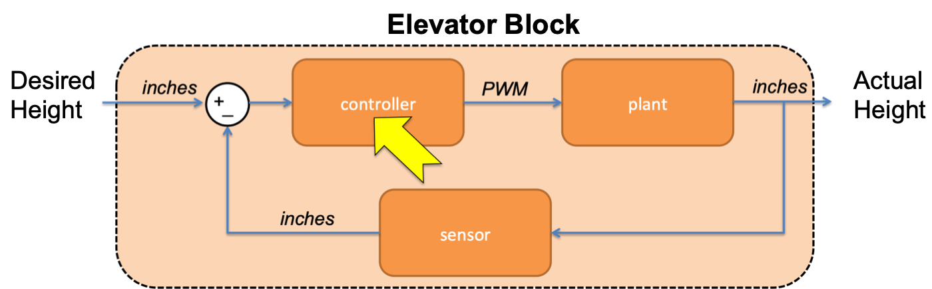

**Lab report is due at the beginning of next lab period**

**Step 1: Improve your Controller**

Write a new function (or improve your original function) in your mbed program to set motor speed based on the error between the desired height and the actual height of the elevator. Consider implementing a proportional controller and/or proportional-integral controller discussed in class.

A proportional controller calculates the duty cycle *proportional* to the height error

$$duty cycle=K_{p}er{ror}_{height}$$

where $K_{p}$ is called the proportional control gain and $error_{height}$ is the height error.

A proportional-integral controller calculates the duty cycle proportional to the height error AND the integral of the height error

$$duty cycle=K_{p}error_{height}+K_{i}∫error_{height}dt$$

where $K_{p}$ is the proportional control gain, $K_{i}$ is the integral control gain, and $∫error_{height}dt$ is the integral of the height error over time.

**Step 2: Evaluate your Best Controller using MATLAB**

Use your MATLAB script from Week 2 to send the elevator to 12”, then to 18”, and finally back to 12” with 250 iterations for each step. The entire program should run for 15 seconds.

Collect the height data over serial and produce a plot with two lines showing the actual elevator height and the desired elevator height over time. The difference between the desired and actual heights is the error. A good controller will have smaller error.

*Deliverable:*

Plot the entire elevator run as described. Make sure the plot has a legend, title, and axis labels. In a few sentences describe the limitations of your controller. These results will go in your final report.

**Step 3: Write a Report Presenting All of Your Findings**

The final deliverable for Lab 5 is a detailed report presenting all of your results from the last 3 weeks. This is a technical report, so the goal is to present all the necessary information as concisely as possible.

A good lab report will tell a complete story from start to finish. The abstract is like a synopsis that summarizes the report (including major results) in a few sentences. Then the report is divided into sections that tell the story in more detail. Think about what you have accomplished, and structure your “story” into sections. For example, an outline for your report might be divided into the following sections:

* 1. **Abstract:** The abstract is a single paragraph overview of the entire report. Write it last, when you know what you are summarizing. The abstract should provide a big picture view of what you accomplished. It may include specific, significant findings. Other engineers, scientists, funding agencies, bosses, etc. may read your abstract to decide if they want to learn more by reading the full report.
  2. **Introduction:** In a formal report, the introduction sets the stage for the rest of the report. You should provide context for the design problem or research question you plan to address. If there are important pieces of background, that a generally smart engineer would need to understand your work, you should introduce them here. In future reports later in the systems engineering major, you might include a literature review here, this is **not** needed for this report.
  3. **Methods:** After the introduction, write down the methods you used so that your work can be replicated. Specific to this lab, this section provides an overview of the hardware, software, and calibrations you used. This section can mostly be written even before the experiments are done, which is why you wrote a preliminary hardware section as your deliverable for Lab 4. Feel free to re-use that description, but update it now that you know more about the elevator. If it makes sense and makes it easier to read and understand, you may subdivide this into sections dealing with important, bite-sized chunks.
     + 1. **Hardware overview** of the elevator system (may include block diagram), which you already wrote for Lab 4.
       2. **mbed/Matlab interface** explain how measurements were made, and how data were received for plotting.
       3. **Calibration** of sensors must be discussed (and coefficients provided) if someone wants to replicate your results.
  4. **Results and discussion:** The results are presented here followed by a discussion of the significance of the findings. You have already written a results/discussion session for Lab 2; the general idea here will be similar. As before, if it makes sense and makes it easier to read and understand, you may subdivide this into sections presenting important, bite-sized chunks. A good way to organize this section might be to treat each control algorithm in its own sub-section. This section should be quantitative, precise, and must include well-labeled plots[1]. Results and discussion are mostly in present tense when referring to plots.
     1. **Logic control** results and discussion from Week 2.
     2. **Proportional control** results and discussion from Week 2-3.
     3. **(Optional) Proportional-integral control** results and discussion from Week 2-3.
     4. If you tried any other methods or examined filtering or advanced control, feel free to include it in the final lab report, potentially for extra credit.

1. **Control performance analyses and comparisons:** You’ve done all this work, but **so what?** Show the value of what you have learned/discovered about the control algorithms. How do they compare in terms of performance? A customer or user cares about how it compares with the other controllers. Which one worked best?
2. **Conclusions:** Conclusions should establish the value of what you have learned, and may relate it to bigger picture things outside of the particular system you studied, i.e. the significance, writ large, of your work. A busy reader may read only your abstract, browse your figures, then read your conclusion; so you want to load it with the major take-aways that you want people to gather from your work. Word of caution here, don’t oversell your work; you’ve studied some control algorithms that might be useful, but if you claim your work will revolutionize warfighting, cure cancer, detect life on Mars, or enable cold fusion, your conclusion may be over-sold.
3. **Acknowledgements, comments, references:** It is customary to acknowledge help from lab partners, or significant help from buddies or TSD, funding provided for equipment, etc. (the latter ones not needed for EW202). You may also wish to include helpful, constructive comments about what might be improved in the lab. Generally, at the end of a report, you would also include references for any citations; you do not need these for EW202 but may need them in future reports (e.g. capstone EW404).

*Deliverable:*

Lab 5 report

1. Include captions for your plots; a reader who is strapped for time may read only your abstract, browse your figures, then read your conclusion.